

|  |  |  |  |  |  |  |  |  |
| --- | --- | --- | --- | --- | --- | --- | --- | --- |
|  | | | | | | | | |
|  | | FUNDUS DISEASE CLASSIFICATION | | | | |  | |
|  |  | | | | | | |  |
|  | | | |  |  | | | |
|  | | | |  |  | | | |
|  | | | | Ravi KandulnaV.Sivakumar06.04.2024Data Science Project Karunya Institute of Technology and Sciences, Coimbatore. |  | | | |
|  | | |  | | |  | | |

**Table of Contents**

1. Introduction
2. Objective
3. Dataset
4. Algorithm
5. Software
6. Libraries
7. Output

**Fundus Disease Classification**

**Chapter 1**

1. **Introduction**

The human eye is a complex organ, and various diseases affecting the retina can lead to vision impairment or even blindness if not diagnosed and treated promptly. Fundus imaging, which captures images of the retina, has become an essential tool for diagnosing such diseases. In recent years, the application of deep learning techniques, particularly convolutional neural networks (CNNs), has shown promising results in automating the analysis of fundus images for disease prediction.

This project aims to leverage CNNs to predict the presence of various retinal diseases based on fundus images. We will utilize a dataset containing a diverse range of fundus images, each labeled with the corresponding disease or condition. The dataset will be preprocessed to ensure consistency and quality, including resizing, normalization, and augmentation to enhance model generalization.

The choice of using Jupyter Notebook within the Anaconda IDE provides a seamless and interactive environment for developing and presenting the project. Jupyter Notebook facilitates the integration of code, documentation, and visualizations, making it an ideal platform for exploratory data analysis and model development. Anaconda, on the other hand, offers a comprehensive Python ecosystem with pre-installed libraries and tools essential for data science and machine learning tasks.

**Chapter 2**

1. **Objective**

The primary aim of this project is to develop a convolutional neural network (CNN) model capable of accurately predicting retinal diseases based on fundus images. By leveraging deep learning techniques, particularly CNNs, the project intends to automate the process of diagnosing various retinal conditions, including diabetic retinopathy, age-related macular degeneration, and glaucoma.

This automation aims to address the challenges associated with manual inspection, such as time consumption and subjectivity, while potentially improving diagnostic accuracy and efficiency. Additionally, the project seeks to create a scalable and accessible solution that can be deployed in diverse healthcare settings, including clinics, hospitals, and remote areas.

Leveraging open-source tools like Jupyter Notebook and Anaconda, the project aims to develop a user-friendly system that can be easily deployed and maintained, even by users with limited technical expertise. Rigorous validation experiments will be conducted to assess the model's performance using standard evaluation metrics and compare it with existing approaches and benchmark datasets. Furthermore, the project emphasizes enhancing the interpretability and transparency of the CNN model to foster trust and acceptance among healthcare professionals and end-users. By achieving these objectives, the project aims to contribute to the advancement of automated retinal disease diagnosis, ultimately improving patient outcomes and public health.

**Top of Form**

**Chapter 3**

**3.Dataset**

The dataset used in this project consists of a diverse range of eye images, encompassing various types of retinal conditions as well as normal images. Specifically, it includes images representing the following categories:

1. Cataract Images: Cataract refers to the clouding of the lens inside the eye, leading to blurry vision. The dataset contains images depicting the characteristic features associated with cataracts, such as opacity or discoloration of the lens.
2. Glaucoma Images: Glaucoma is a group of eye conditions that damage the optic nerve, often due to increased pressure within the eye. The dataset includes images showing signs indicative of glaucomatous damage, such as optic disc cupping, visual field defects, and retinal nerve fiber layer thinning.
3. Diabetic Retinopathy Images: Diabetic retinopathy is a complication of diabetes that affects the blood vessels in the retina, leading to vision loss if left untreated. The dataset comprises images showcasing various stages of diabetic retinopathy, including microaneurysms, hemorrhages, exudates, and neovascularization.
4. Normal Images: In addition to images depicting retinal conditions, the dataset also contains normal eye images. These images serve as a reference for healthy retinal anatomy and aid in distinguishing pathological changes from normal variations.

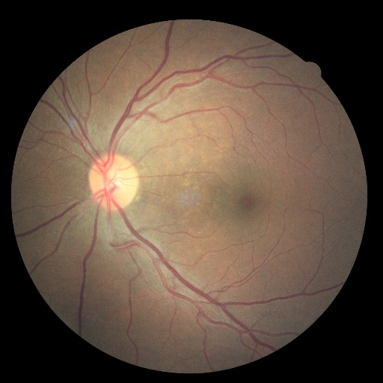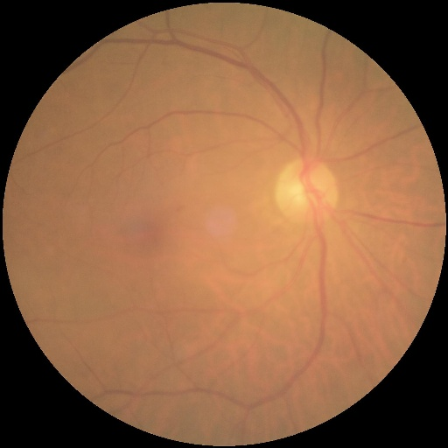

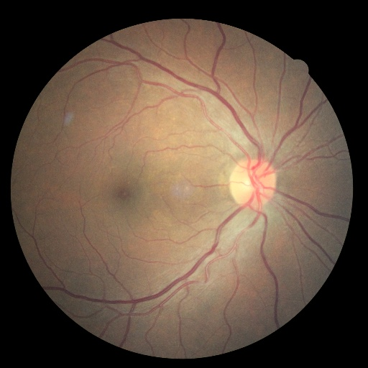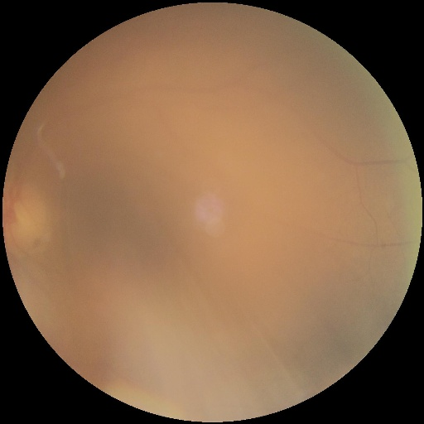

**b. Diabetic Retinopathy**

1. **Cataract eye**

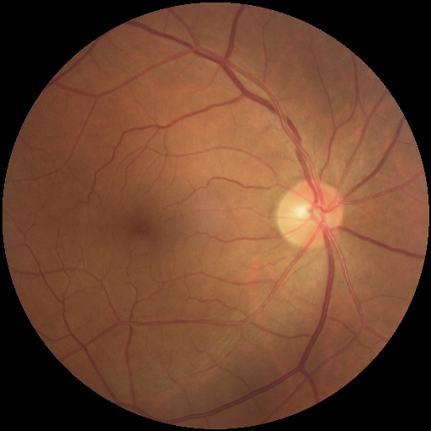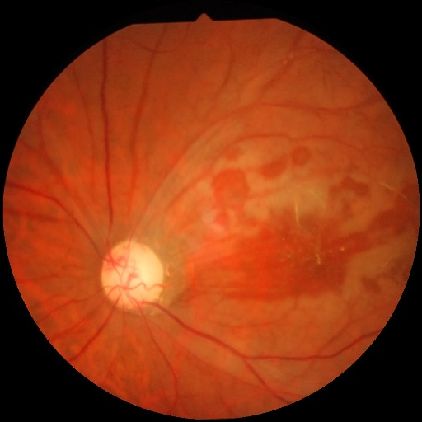

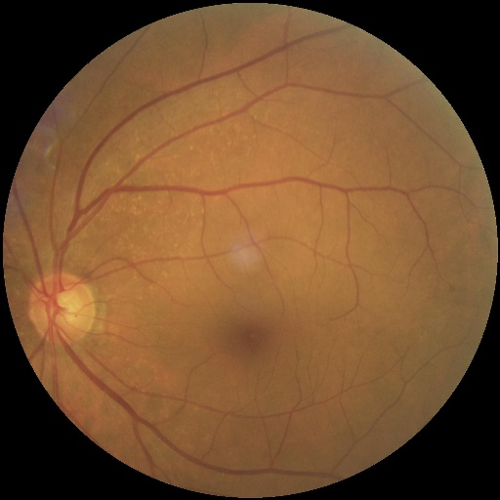

**d. Normal**

**c. Glaucoma**

**Chapter 4**

**4.Algorithm**

* Convolutional neural network – Multiple classification

In this study, we explore the application of Convolutional Neural Networks (CNNs) for the classification of four types of eye diseases: cataract, glaucoma, diabetic retinopathy, and normal images. CNNs are particularly well-suited for image classification tasks due to their ability to automatically learn hierarchical features from raw pixel data.

We begin by introducing the CNN architecture, highlighting its convolutional layers, pooling layers, and fully connected layers, which enable effective feature extraction and classification. The classification of eye diseases holds significant clinical importance, as early detection and diagnosis are crucial for timely treatment and prevention of vision loss. We utilize a dataset containing a diverse range of eye images, including pathological conditions and normal variations, and preprocess it to ensure uniformity and quality.

Our CNN model is trained using this dataset, with data augmentation techniques employed to increase variability and prevent overfitting. We evaluate the model's performance using standard metrics such as accuracy, precision, recall, and F1-score on a separate test set. Interpretability and transparency of the model's predictions are also addressed, emphasizing the importance of understanding the decision-making process in medical applications

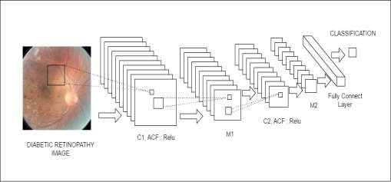

4.1. CNN Algorithm

**Chapter 5**

**5.Software**

**5.1 : Visual studio code**

In this project, we utilize Visual Studio Code (VS Code) as our primary integrated development environment (IDE) for software development and management. VS Code, developed by Microsoft, offers a versatile and lightweight environment suitable for Python development, making it an excellent choice for our project needs. One of the key advantages of VS Code is its customizable user interface, which allows us to tailor the editor layout and functionality to our preferences.

The IDE provides a wide range of features for code editing, including syntax highlighting, code completion, and integrated terminal support, facilitating efficient coding workflows. Additionally, VS Code offers seamless integration with version control systems such as Git, enabling collaborative development and streamlined code management. Its built-in debugging capabilities allow us to identify and troubleshoot issues effectively, ensuring the reliability and quality of our software. Furthermore, VS Code supports the installation and management of Python packages via its integrated package manager, simplifying the process of managing dependencies for our project.

Overall, Visual Studio Code serves as a flexible and powerful development environment, empowering us to build, test, and deploy our software with ease.

**5.2 : Python code**

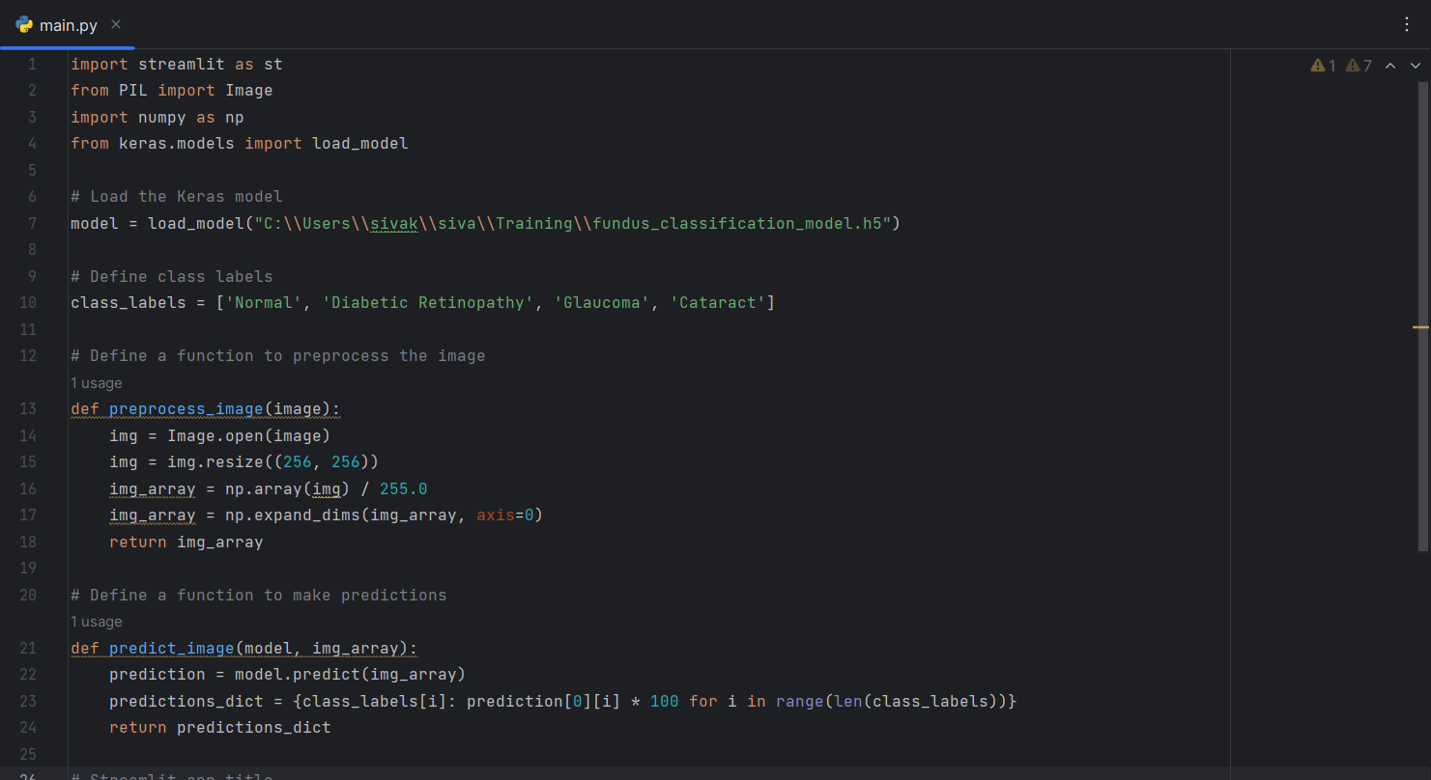

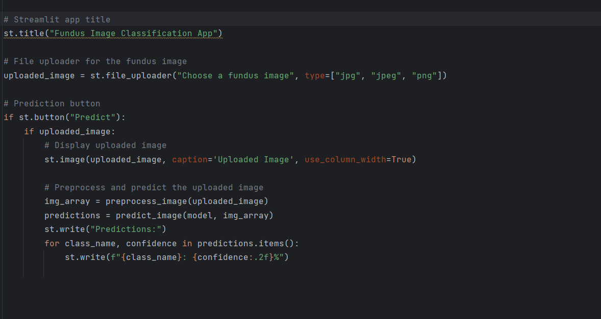

**5.3: Training code**

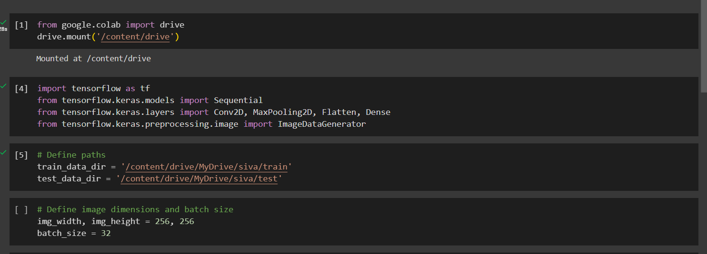

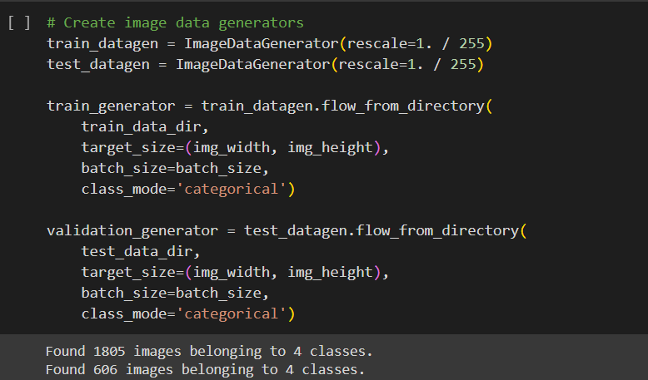

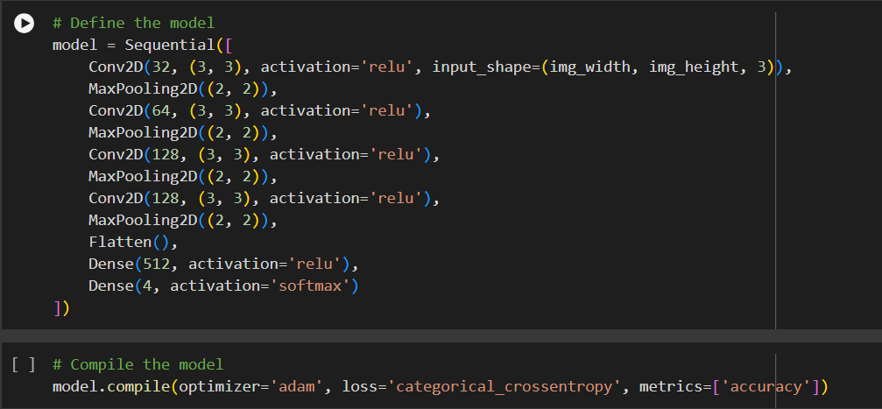

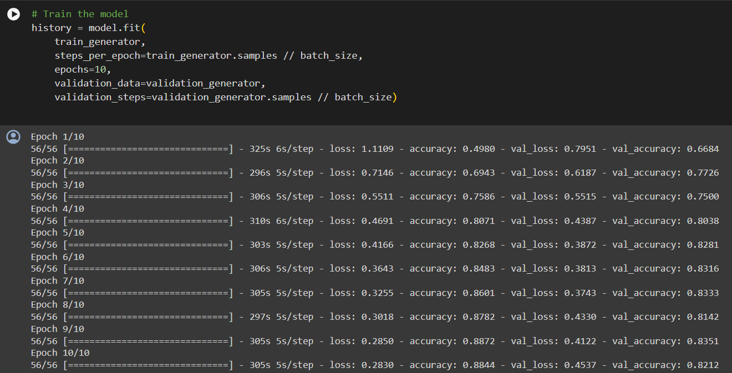

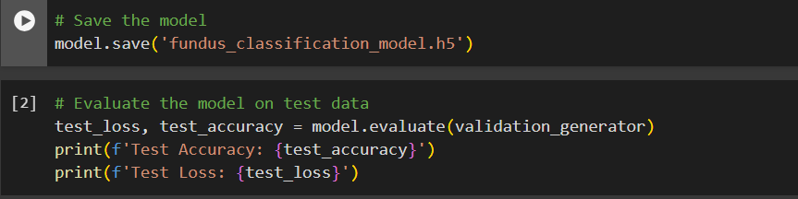

**Chapter 6**

**6.Libraries**

**6.1: Streamlit**

Streamlit is a Python library designed to simplify the creation of web applications for data science and machine learning projects. It offers an intuitive and Pythonic syntax, allowing users to build interactive web apps directly from Python scripts without the need for HTML, CSS, or JavaScript coding. With a wide range of built-in widgets such as sliders, buttons, and dropdown menus, Streamlit enables users to incorporate user interaction seamlessly.

One of its standout features is automatic reactivity, ensuring that the web app's interface updates dynamically in response to changes in code or data. Streamlit integrates smoothly with popular data libraries like Pandas, Matplotlib, and Plotly, enabling users to create interactive visualizations and dashboards effortlessly. Moreover, Streamlit supports flexible deployment options, including local hosting, cloud platforms, and containerized environments, making it easy to share and deploy apps with collaborators or stakeholders.

With customization options for appearance and theming, Streamlit empowers users to personalize the look and feel of their web apps to match their preferences or branding. Overall, Streamlit simplifies the process of building and sharing interactive web applications, allowing data scientists and machine learning practitioners to focus on their analysis and insights.

**6.2: Tensor Flow**

TensorFlow is a powerful open-source machine learning framework developed by Google, widely used for building and training various deep learning models. It provides a flexible and comprehensive ecosystem for developing machine learning applications, including neural networks, natural language processing, computer vision, and more.

TensorFlow's key features include a high-level API (such as Keras) for rapid prototyping, distributed computing capabilities for scaling training across multiple devices or servers, and support for deployment on various platforms, including desktop, mobile, and cloud environments.

With TensorFlow, developers can efficiently build and train complex machine learning models using its extensive collection of pre-built components and tools, enabling innovation and advancement in the field of artificial intelligence.

**6.3: Pillow**

The Pillow library, also known as Python Imaging Library (PIL), is a widely-used open-source Python library dedicated to image processing tasks. It offers an extensive range of functionalities for working with images, including loading and saving images in various formats such as JPEG, PNG, GIF, BMP, and TIFF. Pillow provides intuitive methods for manipulating images, allowing users to perform tasks like resizing, rotating, cropping, and adjusting image attributes such as brightness and contrast.

Additionally, Pillow offers built-in filters for image enhancement and analysis, including blurring, sharpening, and edge detection. It also supports image drawing and text rendering directly onto images, enabling annotations and visualizations.

Pillow's versatility extends to image conversion and format conversion, facilitating seamless integration with other Python libraries and frameworks. With its user-friendly interface, comprehensive documentation, and extensive range of features, Pillow is an essential tool for developers, data scientists, and researchers working on image processing and computer vision projects in Python.

**6.4:Numpy**

The NumPy library, short for Numerical Python, is a fundamental open-source Python library extensively used for numerical computing tasks. It provides a powerful array object that enables efficient handling of large datasets and multi-dimensional arrays. NumPy offers a wide range of functionalities, including mathematical operations, array manipulation, linear algebra operations, Fourier transforms, and random number generation.

With NumPy, users can perform vectorized operations, enhancing computation speed and code readability. Additionally, NumPy seamlessly integrates with other Python libraries and frameworks, making it a cornerstone for scientific computing, data analysis, and machine learning projects. Its simplicity, performance, and versatility make NumPy an indispensable tool for researchers, engineers, and data scientists seeking to leverage the full potential of Python for numerical computations.

**Chapter 7**

**7.Output**

The output of this project includes a trained convolutional neural network (CNN) model capable of accurately classifying fundus images into four categories: cataract, glaucoma, diabetic retinopathy, or normal. Evaluation metrics such as accuracy, precision, recall, and F1-score demonstrate the model's performance on unseen test data. Visualizations, including confusion matrices and ROC curves, provide insights into the model's classification behavior.

Suggestions for deploying the model, such as through web applications or integration into healthcare systems, are offered. Additionally, avenues for future research, including exploring additional data sources and optimizing model architecture, are discussed to further improve diagnostic accuracy and expand the project's scope.

**7.1: Images**

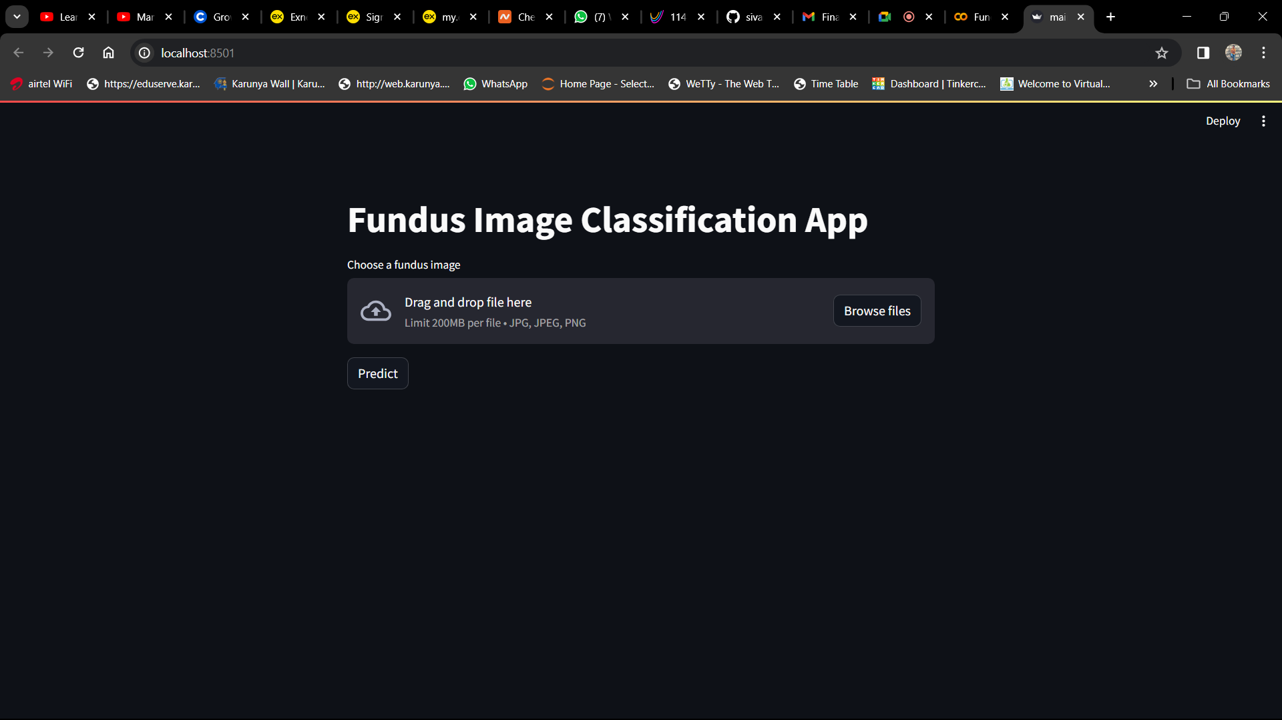

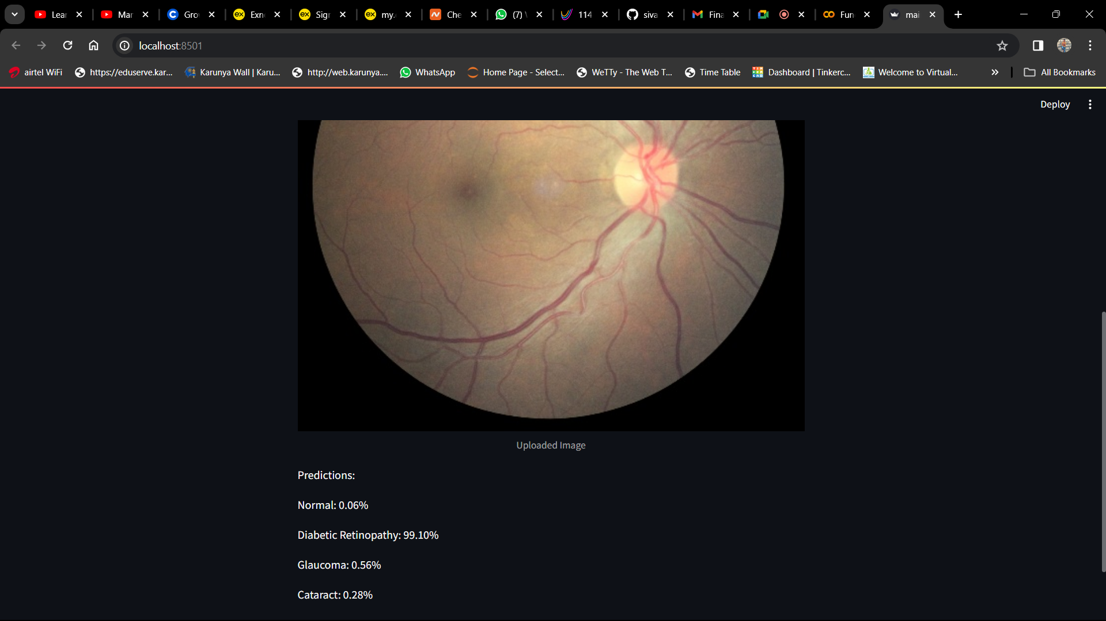

**Inference:**

The dataset is trained and implemented through streamlit library to predict the fundus disease classification

**Reference :**

* Git hub **-** [**https://github.com/sivasans/fundus-disease-classification.git**](https://github.com/sivasans/fundus-disease-classification.git)